**Name:-** Atharva Salitri

**Roll No:-**  29

**Division:** TY CSAI-B

**Batch:-**  2

**PRN:-** 12310120

**Subject:-** Cloud Computing

**Assignment 1**

**Problem Statement:-** To install an OS using VirtualBox/ VMWare Workstation. Add Storage to create new virtual disk.

* **INSTALLATION STEPS :-**

1. Download oracle virtual box from <https://www.virtualbox.org/wiki/Downloads> . Click on

“ Windows hosts “ under VirtualBox 7.0.18 platform packages.

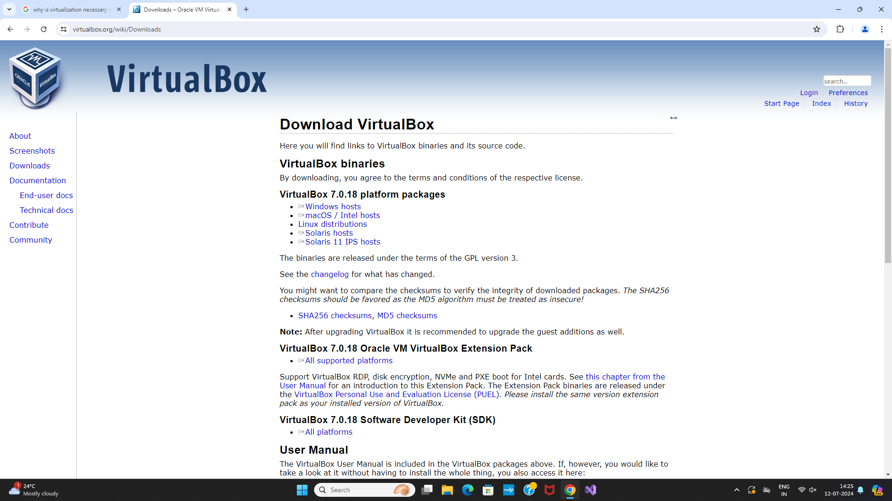

1. After downloading the virtualbox.exe file , Install it.

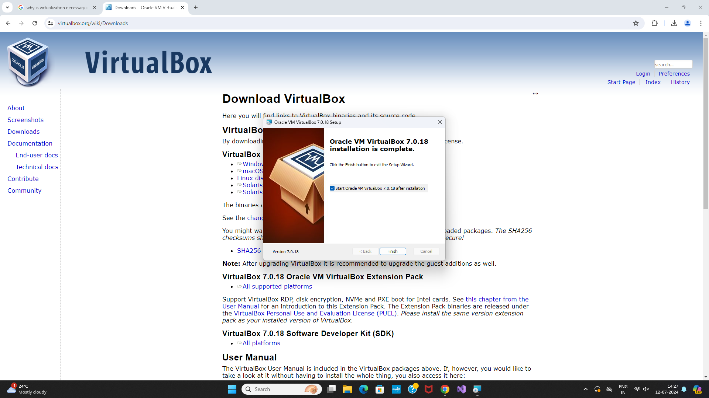

1. Once the installation is complete. Click on “New” to add new OS on VM.

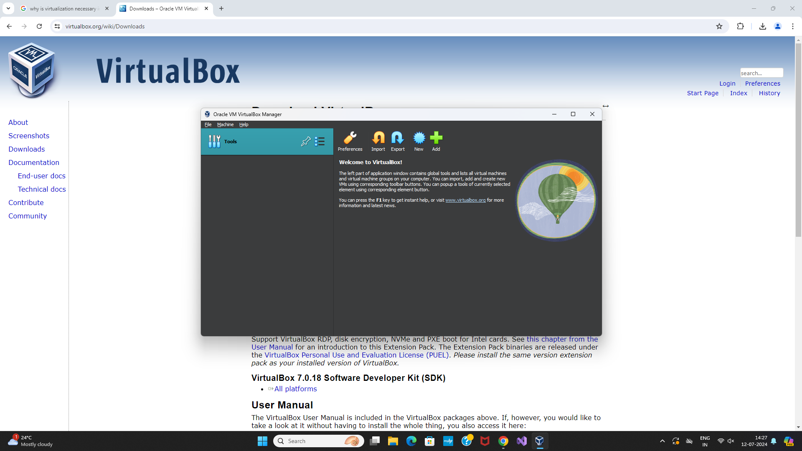

1. On clicking New:

– Write the Name you want for your system, for example: Linux Mint 1

– Select Type: Linux.

– Select Version: Ubuntu.

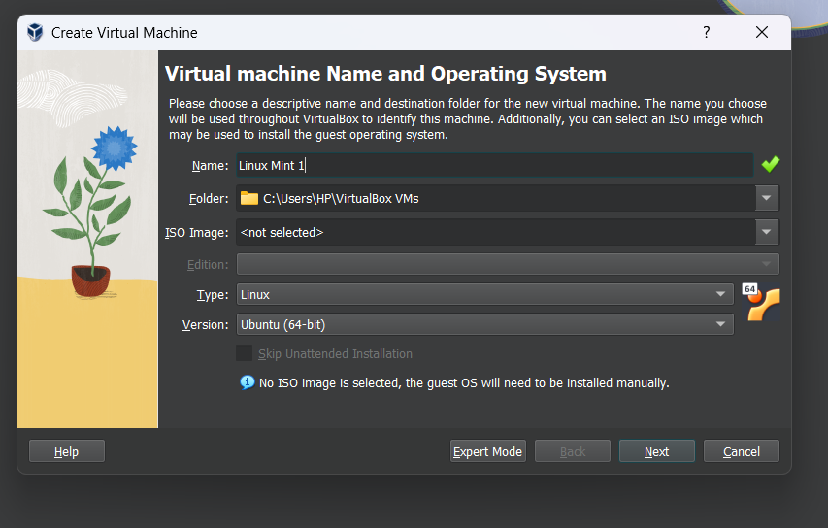

1. Select the amount of RAM and Virtual disk.

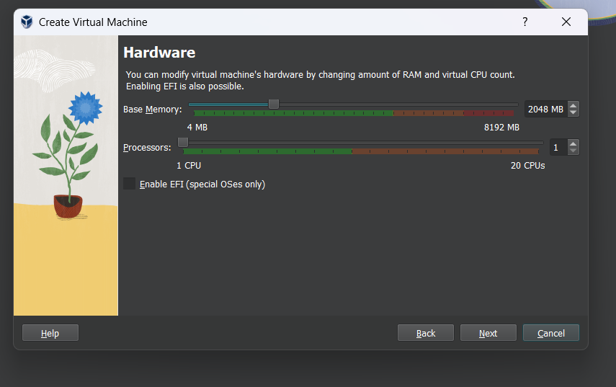

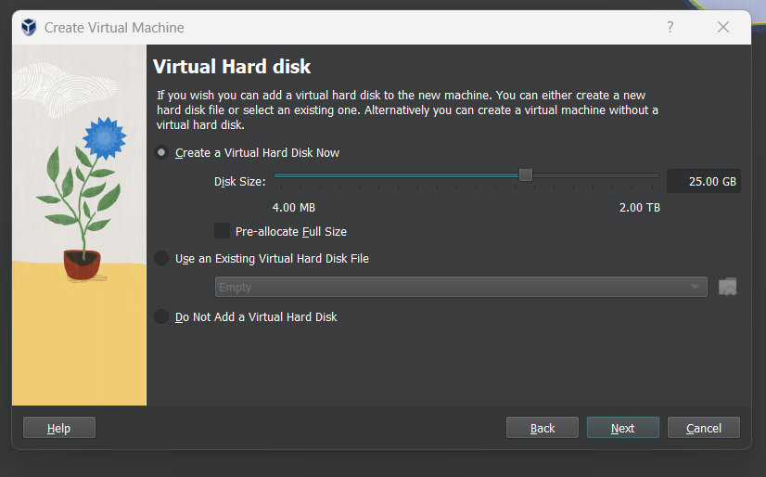

1. Click Finish.

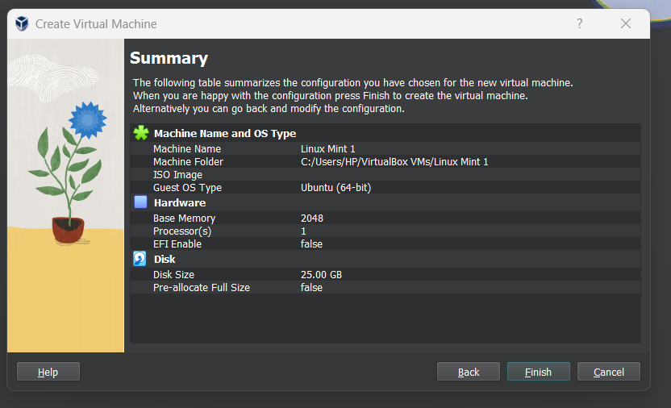

1. Select the downloaded Linux ISO file :-

* Click on start to launch your system

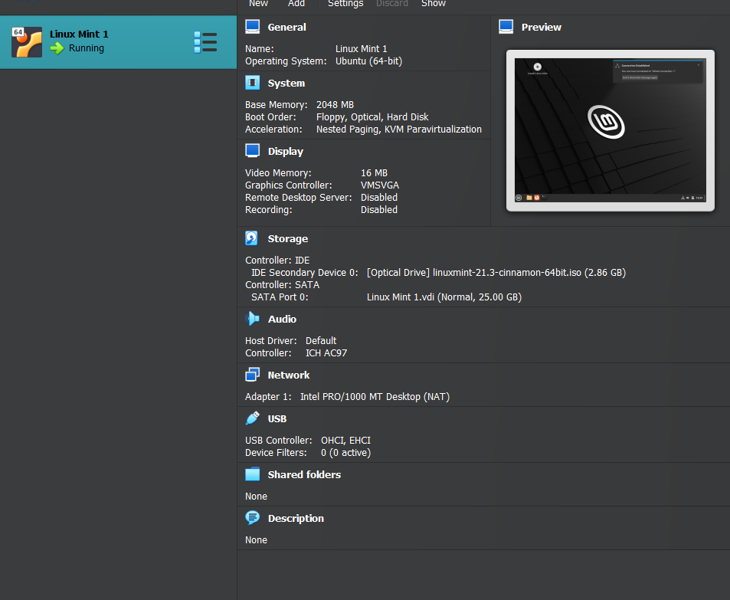

1. Choose the iso file from your computer.

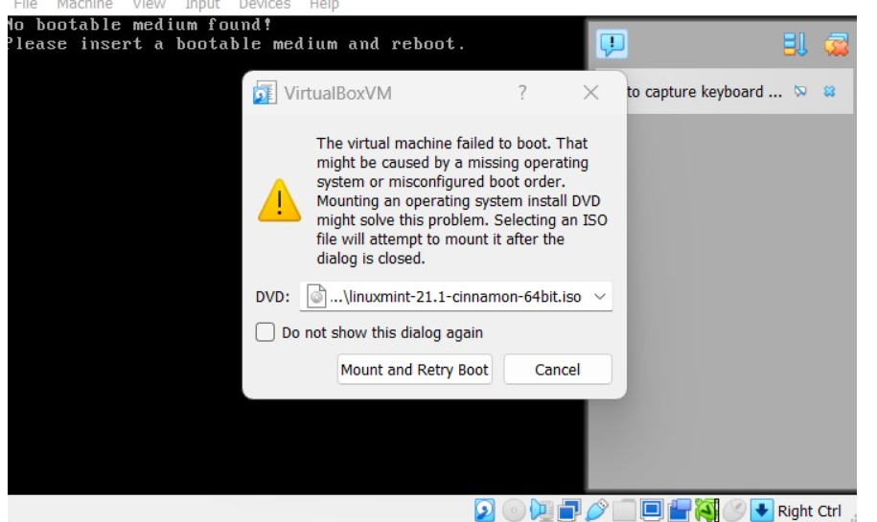

Click Mount and Retry Boot

1. Install Linux – Click install Linux Mint

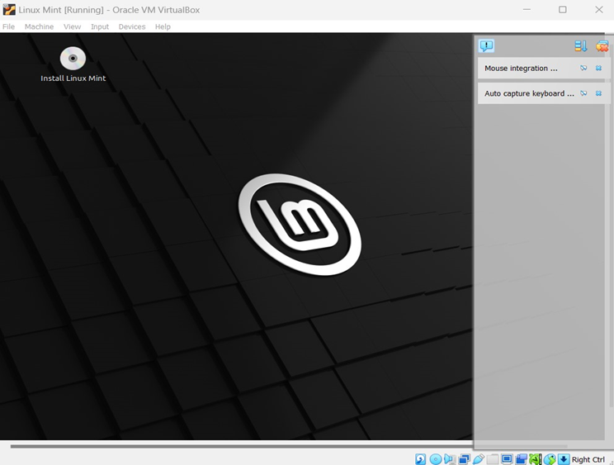

1. Keep clicking continue . Then make your Account , click continue .

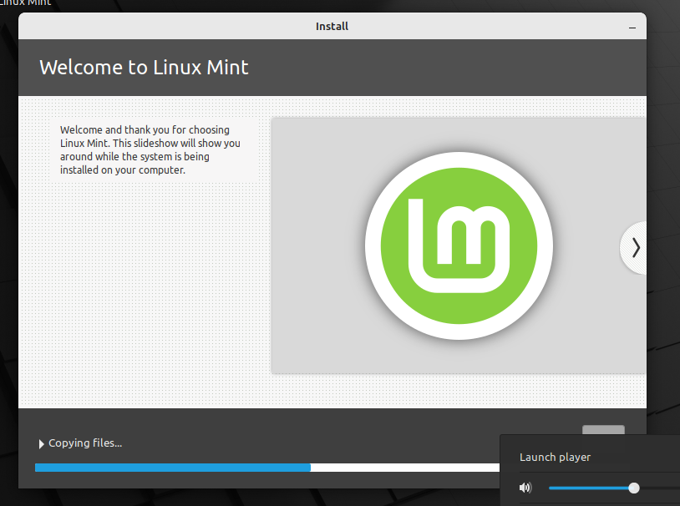

1. Installation completed.

